Develop a Java program to create a class Book with members Book ID, Title, Author, and Price. Use a constructor to initialize the details. Include methods to display book information, overload search() to search by Book ID and Title, and create a method that accepts another Book object and returns the costlier book. Use a static member to maintain the total number of books created. In the main class, create multiple book objects and demonstrate all the operations.

class Book {
int book_id;
String title;
String author;
int price;
static int totalbooks = 0;
Book(int book_id, String title, String author, int price) {
this.book_id = book_id;
this.title = title;
this.author = author;
this.price = price;
totalbooks++;
}
void display() {
System.out.println("ID: " + book_id);
System.out.println("Title: " + title);
System.out.println("Author: " + author);
System.out.println("Price: " + price);
}
void search(int id) {
if(id == this.book_id) {
display();
}
}
void search(String Title) {
if(title.equalsIgnoreCase(Title)) {
display();
}
}
Book costlier(Book b) {
if (this.price > b.price) {
return this;
} else {
return b;
}
}
}
class Main {
public static void main(String[] args) {
Book b1 = new Book(123, "Java", "james", 2000);
Book b2 = new Book(365, "c++", "stanley", 1000);
b1.display();
System.out.println();
b2.display();
System.out.println();
System.out.println("Search ID");
b1.search(123);
System.out.println();
System.out.println("Search title");
b2.search("c++");
System.out.println();
Book expensive = b1.costlier(b2);
System.out.println("The costlier book is: " + expensive.title);
System.out.println("Total books created: " + Book.totalbooks);
}
}

OUTPUT

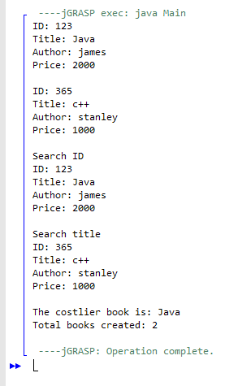

Lohith Sidegal
1BF25CS140

